**@Component**

* **@Component annotation tells that an annotated class is a Spring bean or a spring component**
* **In this case, the spring container automatically create a spring bean (i.e. spring container creates an object to the class and manages it)**

**//create a class**

**@Component**

**public class DeptController{**

**public String getDept(){**

**return "its the Department controller";**

**}**

**}**

**main()**

**{**

**ConfigurableApplicationContext context=SpringApplication.run(AnnotationsApplication.class,args);**

**BookController ob=context.getBean(DeptController.class);**

**System.out.println(ob.getDept());**

**}**

**@Autowired**

**The @Autowired annotation is used to inject the bean automatically**

**It is used in construction injection, setter injection and field injection**

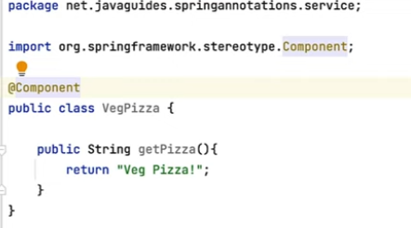

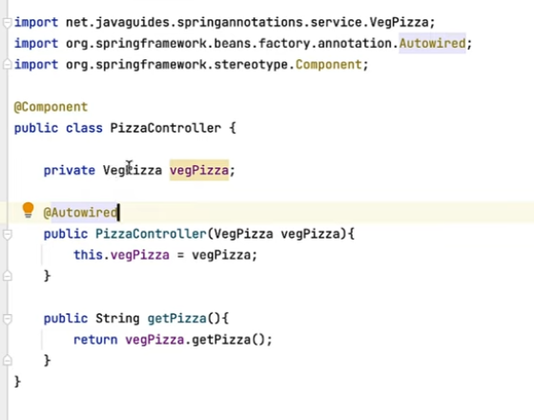

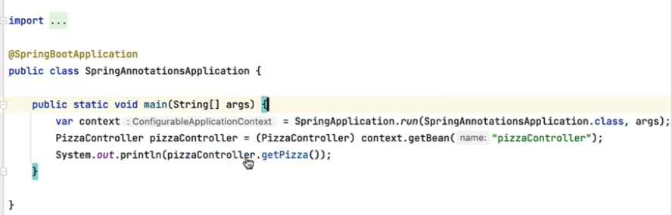

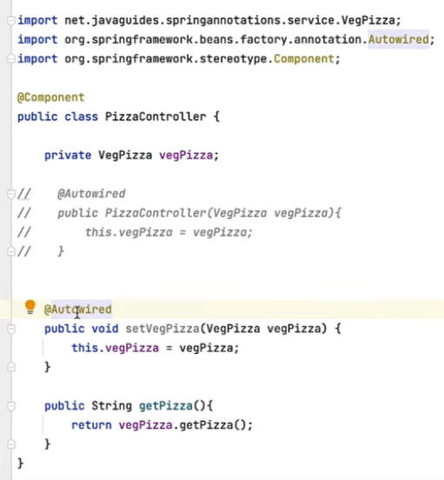

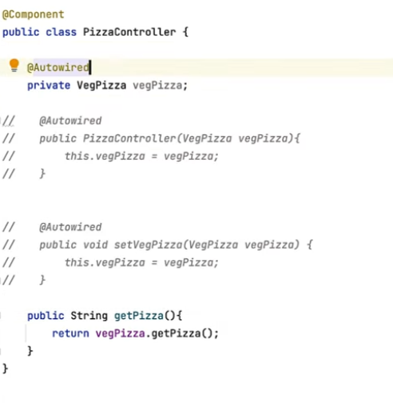

**@Qualifier**

**Used in combination with @Autowired in order to avoid confusion when two or more beans configured for same type**

**Pizza interface**

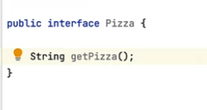

VegPizza implementing Pizza Interface

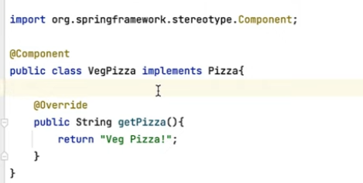

NonVegPizza implementing Pizza Interface

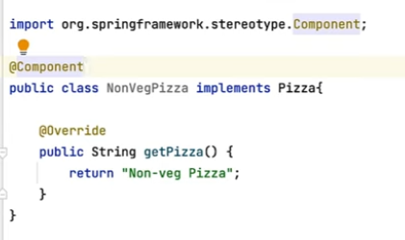

**Class which implements the qualifier**

